Creative women Academy
Connect ..lead …change

Woman's Academy

2010
Prepared by :Fedaa K. ElDerdesawe
0599667251

PROJECT DETAIL

Creative women academy will concerns with women affairs and especially the orphans because they lost their breadwinner so it will improve their skills and experience by providing qualified programs of training that will positioned them to take high position in work which help them to became breadwinner for their families .
So we put the women in the right track for making them qualified to get job
Our creative academy focuses on improving the livelihoods of women and youth in the community through capacity building, creative expression. This blog was set up with the intention to promote women and girls to voice their opinions, hopes and dreams about whatever concerns them, whether it be gender issues, politics or health. With time, this blog will hopefully foster debate, conversation and sharing throughout the world.
Statement of the Problem
More and more unemployed women cannot get jobs. Unemployment became a social violence against women in labor market.
The unemployed women need to be offered, not only the opportunity of acquiring a new vocational training, they also have a real need for education in general and social subjects to increase their life-competency and boost their self-confidence
Goals
The Women’s Center partners with women and girls to build their knowledge, skills and confidence to become self sufficient.
Objectives
- To design and implement training programs for women to improve their specific skills, with the aim of activating their roles in the development process.
- To strengthen the capacity of the staff in the center and the university and to engender the educational programs in the center
- To enhance the role of women in management positions and to offer practical solutions and strategies for addressing the challenges encountered by women in professional life, particularly the economic, profit-making sector.
- To provide a safe, nurturing space for women of all ages to pursue their creative destinies
- To provide women with the opportunity to create and to have that creation received and appreciated by others
Clientele
Women and girls (orphans are preferred) who seek to improve their organizational capacities in leadership, planning, conflict resolution, time-management, communication monitoring, health and assessment skills;
Methods /Activities
The academy offers a wide variety of educational programs that are relevant to the lives we lead today. Programs are divided into several categories: Career Corner, Money Matters, Healthy Relationships, Personal Growth, Separation & Divorce.
Training academy will hold several activities for women such as:

Training Courses
- Professional Management Training Program
- Career Corner
- Business courses (start-up, marketing, financial management, accounting, business expansion, etc)
- Temporary contracts jobs for women
- Political training including women's participation in public life and political campaigns.
- Match Your Head To Your Heart
- Successful Resume Essentials
- Training on presentation skills, building self-confidence, networking, etc).
- Healthy Responses to Anger

- Business promotion (mentoring, contact seminars, and also international seminars).
- Concerts and Festivals
- offer Women practical workshops for the development of their competencies and professional knowledge

These sessions are taught by expert women with a solid expertise in their area and are addressing women directly by understanding their expectations and their challenges. The number of participants depends on the topic, the duration and the methodology, but it never exceeds 25 persons as we would like to guarantee their efficiency and to optimize a pragmatic and interactive approach.
Also we don’t forget women kids if there is no place to put her children we will prepare game room for them.
Assumption
- We assumed that the number of participants to each course will be constant 20 participants.
- Assume that the subjects of courses are the same each month.
- The study period for the project is one year.

Staff/Administration
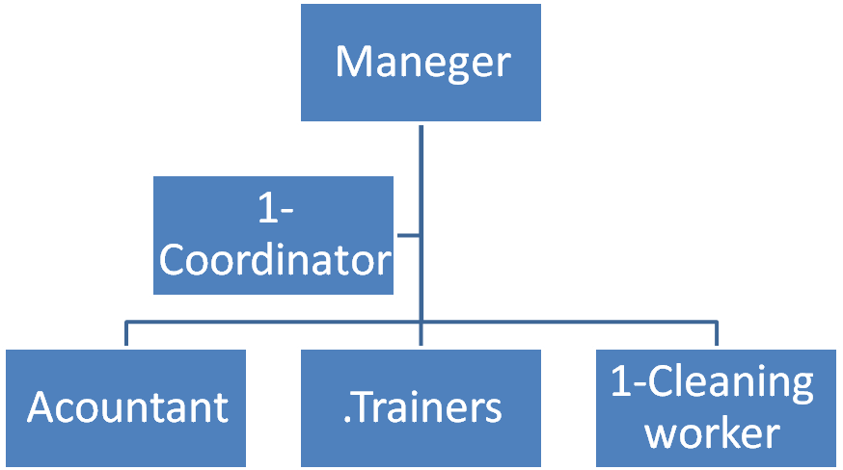

NEEDED RESOURCES
- Personnel
- Manager
- Coordinator
- Accountant
- Trainers
- Cleaning worker
Facilities
Equipment/Supplies/Communication
1 –Needed equipment for management area
Equipments | unit cost($) | Number of units | Total cost($)
Book case | 200 | 2 | 400
desks | 150 | 3 | 450
helping desks | 150 | 2 | 300
Lab top | 800 | 1 | 800
computers | 400 | 1 | 400
Normal chairs for (employee) | 20 | 8 | 160
printer | 150 | 1 | 150
Manager chairs | 125 | 2 | 250
Telephones | 20 | 2 | 40
 |  |  | 2950

2- Needed equipment for computer lab.
Equipments | unit cost($) | Number of units | Total cost($)
Computers and its accessories | 400 | 20 | 8000
computer Tables | 25 | 20 | 500
LCD projector | 1000 | 1 | 1000
Book case | 100 | 1 | 100
Chairs | 20 | 20 | 400
whiteboard | 20 | 1 | 20
Total | 1865 |  | 10020

3- Needed equipment for workshops area
Equipments | unit cost($) | Number of units | Total cost($)
Chairs | 20 | 20 | 400
Tables | 100 | 5 | 500
White board | 20 | 1 | 20
Desk | 150 | 1 | 150
Total |  |  | 1070

4- Needed equipment for Games of mother kids
Equipments | unit cost($) | Number of units | Total cost($)
Table football | 100 | 1 | 100
Table hockey | 50 | 1 | 50
Play tents | 50 | 2 | 100
Bike Trailers | 50 | 3 | 150
Booster Seats | 50 | 5 | 250
Pedal Car Toys | 40 | 4 | 160
Kids Rockers | 50 | 3 | 150
Bulldozer | 50 | 3 | 150
 | 50 | 2 | 100
  Tubtrug
Toys | 40 | 2 | 80
 | 150 | 1 | 150
  Décor
plastic chairs | 10 | 10 | 100
 |  |  | 1440

5- Total assets

Assets | Cost $
Administration room | 2950
computer lab | 10020
workshops room | 1070
child room | 1440
Kitchen and bathroom | 1000
Total cost | 16480

Operating costs
Service | # of units | Cost $
Electricity (kilo watt) | 1200 | 120
water(liter) | 350 | 8.75
fuel(liter) | 15 | 45
Telephone |  | 100
Internet |  | 50
Total |  | 323.75

Expenses per month | Cost $
Renting cost | 400
devices periodic maintenance per month | 10
stationary and petty expenses | 150
Advertising Costs | 100
Insurance Expenses | 100
courses supplies | 15
hospitality | 30
Awards and gifts | 40
First aid supplies | 9
cleaning supplies | 5
Total | 859
Total operating cost | 1182.75

Staff | unit cost($)  per month | Number  of unit | Total cost  $
Manager | 500 | 1 | 500
Secretary | 300 | 1 | 300
Computer engineer | 400 | 1 | 400
Clean worker | 200 | 1 | 200
Trainers | 300 | 3 | 900
Total | 1400 |  | 2300

Activities revenues
Courses | Price/course | Number of participants | Revenues
Professional Management Training Program | 50 | 20 | 1000
Career Corner | 50 | 20 | 1000
Health care courses | 10 | 20 | 200
financial management | 50 | 20 | 1000
Art of Etiquette and Protocol | 20 | 20 | 400
Décor art | 50 | 20 | 1000
Teaching your children | 10 | 20 | 200
English language (conversation -Writing) | 50 | 20 | 1000
Computer programs | 50 | 20 | 1000
Management | 50 | 20 | 1000
Business English for women | 50 | 20 | 1000
Making gifts | 30 | 20 | 600
Courses in Safety | 20 | 20 | 400
Critical thinking courses | 10 | 20 | 200
team building courses | 20 | 20 | 400
Crafts | 20 | 20 | 400
leadership courses | 20 | 20 | 400
Total revenues |  |  | 11200

Profits
Month | expenses | Revenue | profit
May | 19962.75 | 11200 | -8762.75
June | 3482.75 | 11200 | 7717.25
July | 3482.75 | 11200 | 7717.25
August | 3482.75 | 11200 | 7717.25
September | 3482.75 | 11200 | 7717.25
October | 3482.75 | 11200 | 7717.25
November | 3482.75 | 11200 | 7717.25
December | 3482.75 | 11200 | 7717.25
January | 3482.75 | 11200 | 7717.25
February | 3482.75 | 11200 | 7717.25
March | 3482.75 | 11200 | 7717.25
April | 3482.75 | 11200 | 7717.25
May | 3482.75 | 11200 | 7717.25

